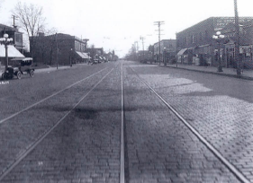Central Avenue Community Forum:
“What’s Up With Central Avenue?”
Monday, April 30, 2012 – 6:30 – 8 p.m.

AGENDA

6:30 p.m. Welcome -- Steve Sylvester …. [other board chairs?]
6:35 p.m. Special Services District Update – Christine Levens
6:45 p.m. Street Repaving Project – Minneapolis Public Works staff [name to come from Reich]
6:55 p.m. Northeast Minneapolis Chamber of Commerce News – Christine Levens
7:05 p.m. Bike Lanes on Central Avenue? – Ward 1 City Council Member Kevin Reich and Bicycle Advisory Commissioner Hope Johnson
7:15 p.m. Crime and Safety – Second Precinct Inspector Bryan Schafer
7:25 p.m. Are Streetcars in Our Future? -- Kevin Reich
7:35 p.m. Northeast Investment Cooperative – name of person?? Correct spelling of org?
7:45 p.m. Community Comments/Question and Answer Session
DRAFT

Thank you to the Salvation Army for the use of this meeting space.
Please keep in mind that the building closes at 8:30 p.m.

