The Logan Park Neighborhood Association has been working with consultants from Cuningham Group Architects since fall 2015 to develop a neighborhood small area plan.
How can I get involved?
- Attend the next public meeting on Februrary 17th, 2016 [insert details]
- Check for updates on the LPNA website [insert website]
- Contact XXXXX if you have questions about the planning process or would like to get involved.
What is a Small Area Plan?
A Small Area Plan is a document that will serve as a guide for future public and private development, investment, and local action within the Logan Park neighborhood. The small area planning process is intended to help the Logan Park neighborhood articulate a collective vision and goals for the future; to illustrate how the neighborhood will look, feel, and function in the future; and to develop a plan of action for the neighborhood association, residents, businesses, property owners, and others with a stake in the future health of the neighborhood.
The Plan will examine a broad range of conditions in the community, including housing and commercial development, demographics transportation, parks and open space, and community identity and cohesion. The plan will include a series of “framework” diagrams that define the physical environment of the neighborhood, as well as implementation strategies and resources that will help translate from plan to action.
Highlights from the Process to Date
The small area planning process consists of three phases of work:
- Gather Data & Understand the Neighborhood (Fall 2015)
- Develop Options & Alternatives (<< We are here!)
- Draft and Refine the Plan (Spring 2016)
Local stakeholders have been involved since the process kicked off this fall, to ensure that the Plan reflects broad concerns and perspectives from across the neighborhood.
The planning team (comprised of LPNA volunteers and consultants) has met regularly with a small area plan steering committee, a group that includes representatives from Logan Park residents, businesses, institutions, and property owners. The steering committee’s role is to advise on and support the development of the plan and the planning process. This group will continue to play an active role in generating and vetting ideas, and reviewing the draft content of the plan.
In November, community members were invited to a public meeting to share their thoughts about the neighborhood, identifying local strengths, weaknesses, and priorities through collaborative mapping exercise. The planning team also hosted a day of focus group discussions in December, meeting with local businesses, property owners, non-profits, and service providers.
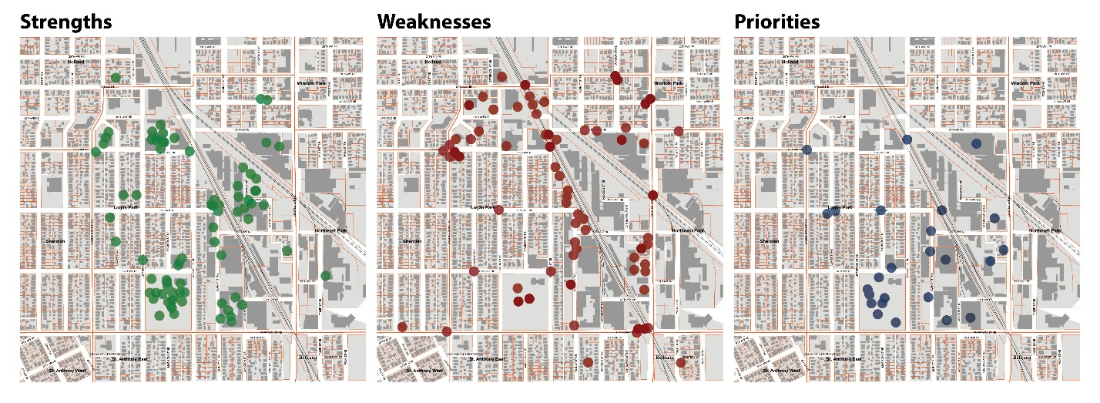
One outcome of these early discussions with stakeholder groups was the development of a draft neighborhood vision statement. The vision statement is intended to express key neighborhood values and aspirations and set a course for future action.
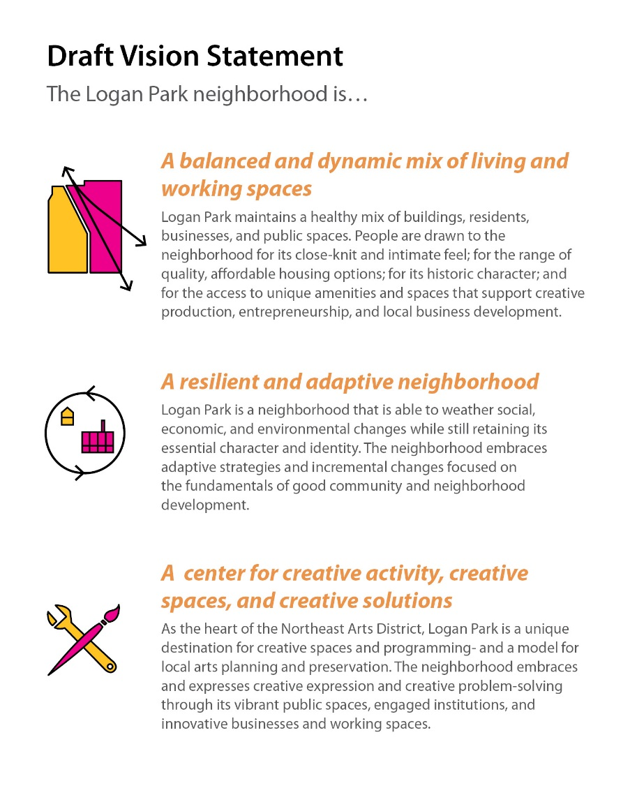
What’s Next: Exploring Possibilities…
The small area planning process is an opportunity for the neighborhood to develop strategies to preserve and maintain existing assets and strengths, as well as an opportunity to look beyond what exists today and plan for future needs. The precedents images below are intended to illustrate a range of possibilities for future development, the park, public spaces, and infrastructure in the neighborhood. These images are a just a small glimpse of the ideas that will be discussed and debated in the coming weeks and months as the small area planning process moves forward.
The February 17th public meeting will focus on exploring these options and alternatives in greater detail- and will provide an opportunity to discuss, generate, and evaluate ideas and recommendations. If you are unable to attend the public meeting, but would like to get involved contact XXXXXXX.
[I suggest picking a half dozen images from the collection below – Think of this as “eye candy” to get them excited/interested in the planning process. I leave it up to you which images you’d like to include]
