LPNA General Meeting, July 18th 2018 7pm @ Logan Park

Introductions

Vote on June General Meeting Minutes – Jeff K makes a motion to pass the minutes, Paula seconds the motion. All vote in favor, motion passes.
Raingarden Lottery – Paula conducted the rain garden lottery. LPNA is sponsoring 12 raingardens, 19 homes expressed interest. We chose 12 homes, the remaining homes will be put on a wait list. All homes will be notified with the outcome.
Survey Presentation – Jeff Klein and Pat Vogel discussed the survey and the results. Our survey had an 11% response rate. The survey was sent in both English and Spanish. All results are available on our website. The survey was the first step in determining neighborhood priorities for project funding. LPNA has almost $200,000 in available funds for new projects. Projects costing under $25,000 can be approved with a board vote. Projects over $25,000 require robust community engagement.
Call for Ideas- Folks presented their ideas to the group. Ideas were written on a whiteboard and at the end of the meeting, people were encouraged to highlight three ideas they supported on the board.
Ideas included:
Workout equipment, Path sidewalk, Strom Drain murals, utility box wraps, street painting, lighting under the bridge, crosswalks and blinky stop sign at 13^{th/} 15th and Monroe, Green roof at Elim, Youth maker space at Elim, Speed bumps, cover graffiti, Logan Park landscaping, logan park solar roof, grants for redirecting storm water, solar garden, community sauna or whirlpool, financial assistance for curb appeal, support for senior services, diverse music series in the park, classes on aging in place/home repair/renters workshops, mark the 45th parallel, narcan & bystander training, expand street lighting, alley beautification, education on trash pickup, better trash bins, alley lighting, bridge painting.
There is not a firm timeline for these projects, though the group would like to have some work done by next summer. Pat recommends to have projects under contract by 2020 even if projects are not completed. We will continue to accept ideas through September. The survey/priorities committee will try to meet later this summer to firm up the details of the process.
Christopher Meyer, Park Commissioner – Christopher stopped by our meeting to introduce himself to the neighborhood. He encouraged folks to view the East of the River Master Plan for Logan Park and to submit comments.

Meeting Adjourns 8:45

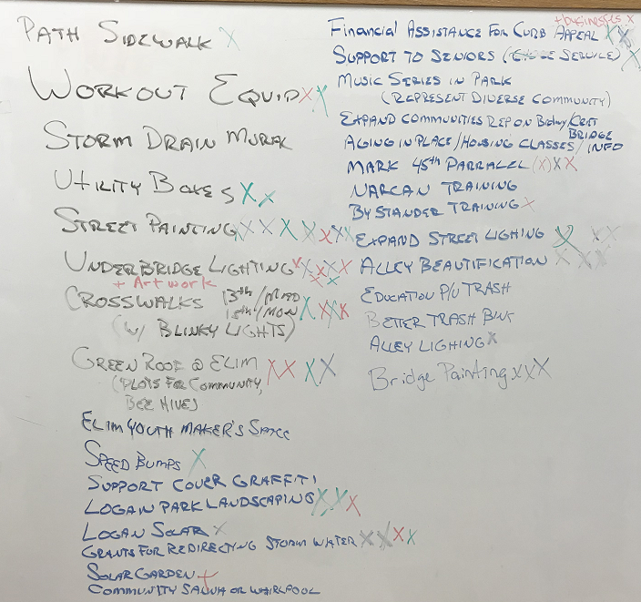
Photo of Ideas captured on a whiteboard, folks were encouraged to mark three ideas they liked best

